Министерство науки и высшего образования Российской Федерации Федеральное государственное автономное учреждение высшего образования «Пермский национальный исследовательский политехнический университет»

ПНИПУ

**Лабораторная работа**

**"Классы №9”**

Выполнил:   
студент группы РИС-23-1б   
Агзамов Артур Альферович

Проверила:   
доцент кафедры ИТАС   
О.А. Полякова

2024 г.

**Задача:**

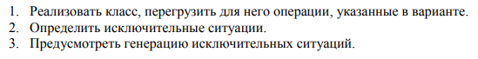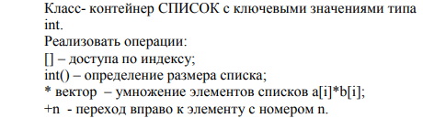

**Анализ задачи:**

**Код:**

#include"class-9-error.h"

#include"class-9.h"

#include<iostream>

#include<string>

using namespace std;

int main(){

system("chcp 1251>null");

system("cls");

system("chcp 1251");

system("cls");

List sp1,sp2;

int count,x,index,h;

cout << "Enter element count: ";

cin >> count;

try

{

if (count < 1) throw error_empty();

cout << "Enter element of list: ";

for (int i = 0; i < count; ++i)

{

cin >> x;

sp1.push_back(x);

}

cout << "Enter index of list number 1 for calling: ";

cin >> index;

cout << "Enter element with this index: " << sp1[index] << endl;

cout << "Enter index of right element of list sp1: ";

cin >> h;

cout << "element with this index: " << sp1+h << endl;

cout << "Size of lsit : " << sp1() << endl;

cout << "Enter count of element of list number 2: ";

cin >> count;

if (count < 1) throw error_empty();

cout << "Enter element of list: ";

for (int i = 0; i < count; ++i)

{

cin >> x;

sp2.push_back(x);

}

sp1* sp2;

cout << "List obtained by multiplying two lists: ";

cout<<sp1<<endl;

}

catch (Error& a)

{

a.what();

}

return 0;

}  
#pragma once

#include<string>

#include<iostream>

using namespace std;

class Error{

protected:

string msg;

public:

virtual void what(){};

};

class IndexError:public Error{

protected:

string msg;

public:

IndexError(){msg="Index Error\n";}

virtual void what(){cout<<msg;}

};

class Index_min_error:public IndexError{

protected:

string msg_;

public:

Index_min_error(){IndexError();msg_="Index<MinIndex\n";}

virtual void what(){cout<<msg<<msg_;}

};

class Index_max_error:public IndexError{

protected:

string msg_;

public:

Index_max_error(){IndexError();msg_="Index>MaxIndex\n";}

virtual void what(){cout<<msg<<msg_;}

};

class size_error:public Error{

protected:

string msg;

public:

size_error(){msg="Index Error\n";}

virtual void what(){cout<<msg;}

};

class error_empty :public size_error

{

protected:

string msg_;

public:

error_empty(){size_error();msg_ = "empty list";}

virtual void what(){cout<<msg<<msg_;}

};

class error_diff_size :public size_error

{

protected:

string msg_;

public:

error_diff_size(){size_error();msg_= "Diff size of list";}

virtual void what(){cout<<msg<<msg_;}

};  
#pragma once

#include <iostream>

#include <vector>

using namespace std;

struct Node {

public:

int data;

Node* next;

Node* prev;

};

class List {

private:

int size;

Node* head;

Node* tail;

friend ostream& operator<<(ostream& out, const List& list);

friend istream& operator >> (istream& in, const List& list);

public:

List() : size(0), head(nullptr),tail(nullptr) {}

void push_back(int data){

Node* new_node = new Node;

new_node->data=data;

new_node->next=nullptr;

if(this->head==nullptr)

{

this->head=new_node;

this->tail=new_node;

}

else

{

tail->next = new_node;

new_node->prev = tail;

tail=new_node;

}

this->size++;

}

void push_front(int data){

Node* new_node = new Node;

new_node->data=data;

if(this->head==nullptr)

{

this->head=new_node;

this->tail=new_node;

this->size++;

}

else

{

head->prev = new_node;

new_node->next = head;

head=new_node;

this->size++;

}

}

int front(){

return this->head->data;

}

int back(){

return this->tail->data;

}

int pop_back(){

int temp;

if(this->tail!=nullptr){

Node * current_node= this->tail;

tail=current_node->prev;

temp=current_node->data;

tail->next=nullptr;

this->size--;

}

return temp;

}

int pop_front(){

int temp;

if(this->head!=nullptr){

Node * current_node= this->head;

head=current_node->next;

temp=current_node->data;

head->prev=nullptr;

this->size--;

}

return temp;

}

bool is_empty(){

return this->size==0;

}

List& operator = (const List& list){

cout<<"Operator ="<<endl;

if(this == &list){

return *this;

}

while (head!=nullptr){

Node* temp=head;

head=head->next;

delete temp;

}

size =0;

Node* current_node=list.head;

while(current_node!=nullptr){

push_back(current_node->data);

current_node=current_node->next;

}

return *this;

}

int& operator [](int index){

if (index < 0) throw Index_min_error();

if (index >= size) throw Index_max_error();

if(index <this->size&&index>=0){

Node* current_node = this->head;

for(int i=0;i!=index;i++){

current_node=current_node->next;

}

return current_node->data;

}

else{

cerr<<"index out of range";

exit(0);

}

}

int operator +(int h)

{

if (h < 0) throw Index_min_error();

if (h >= size) throw Index_max_error();

Node* c = head;

for (int i = 0; i < h; ++i)

c = c->next;

return (c->data);

}

int operator () (){

if(size==0)throw error_empty();

return this->size;

}

List operator * (List& list){

if (this->size != list.size)

{

throw error_diff_size();

}

int temp_size;

if(this->size>list.size){

temp_size=list.size;

}

else

{

temp_size=this->size;

}

List temp(temp_size,0);

for(int i=0;i<temp_size;i++){

temp[i]=(*this)[i]*list[i];

}

return temp;

}

List(int size,int data){

this->size=size;

if(size>0){

Node* node = new Node;

node->data=data;

this->head=node;

this->tail=node;

for(int i=1;i<size; i++){

Node* newNode = new Node;

newNode->data=data;

tail->next = newNode;

newNode->prev = tail;

tail=newNode;

}

tail->next=nullptr;

}

else

{

this->head=nullptr;

this->tail=nullptr;

}

}

List(const List& list)

{

this->head=nullptr;

this->tail=nullptr;

this->size=0;

Node* current_node=list.head;

while(current_node!=nullptr){

push_back(current_node->data);

current_node=current_node->next;

}

};

List(int size){

this->size=size;

if(size>0){

Node* node = new Node;

this->head=node;

this->tail=node;

for(int i=1;i<size; i++){

Node* newNode = new Node;

tail->next = newNode;

newNode->prev = tail;

tail=newNode;

}

tail->next=nullptr;

}

else

{

this->head=nullptr;

this->tail=nullptr;

}

};

~List()

{

Node* current_node=head;

while(current_node!=nullptr){

Node* next=current_node->next;

delete current_node;

current_node=next;

}

head=nullptr;

};

};

ostream& operator<<(ostream& out, const List& list){

out <<endl<< "Elements of list"<<endl;

Node* current_node = list.head;

while (current_node!=nullptr)

{

out<<current_node->data<< " ";

current_node=current_node->next;

}

out<<endl<<"conclusion end"<<endl;

return out;

}

istream& operator >> (istream& in, const List& list){

cout<<endl<<"Enter element of list"<<endl;

Node* current_node=list.head;

while (current_node!=nullptr){

in>>current_node->data;

current_node=current_node->next;

}

cout<<endl<<"Enter element stop"<<endl;

return in;

}

**UML диаграмма:**

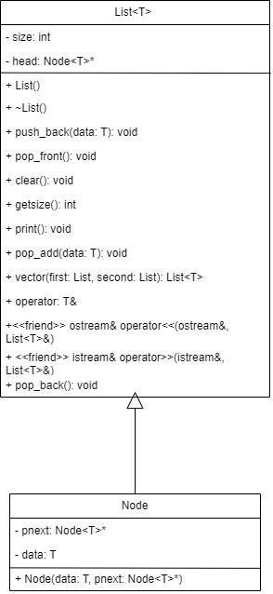

Скрины из git:

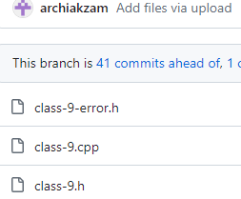

**Выводы:** программа сработала корректно и вывела все возможные решения.